

March 2011
Brought to you by .
National Poison Prevention Week is March 20-26 – are you informed on how to protect yourself and your family from hazardous substances?
According to the Poison Prevention Week Council, more than 2 million instances of poisoning are reported each year in the United States – and more than 90 percent of these poisonings occur in the home.
Prevent poisonings by following these tips:
Lock or secure all medications and chemicals. This is the easiest way to keep children away from hazardous substances in your home.
Continued on page 2…


Healthy Colors

Poison Prevention

The 2011 National Nutrition Month® theme is “Eat Right with Color,” which means making sure your plate has a variety of color and nutrients at each meal. The American Dietetic Association offers a color guide:
Red fruits and vegetables are heart-healthy, help immunity and may reduce cancer risks. Try beets, cherries, cranberries, pomegranate, red grapefruit, red potatoes, red grapes, rhubarb, tomatoes and watermelon.
Orange and yellow fruits and vegetables contain nutrients that contribute to vision, immunity and may reduce the risk of some cancers. Great choices include apricot, cantaloupe, carrots, grapefruit, mango, papaya, peach, pineapple, sweet potatoes, yellow corn and yellow peppers.
Green fruits and vegetables have a high antioxidant potential. Try artichoke, asparagus, avocado, apples, broccoli, grapes, green peppers, honeydew, kiwi, lime and spinach.
Blue and purple fruits and vegetables may have antioxidant and anti-aging benefits. They may also help with memory, urinary tract health and reduce cancer risks. Great choices include blackberries, blueberries, eggplant, plums, purple cabbage and raisins.

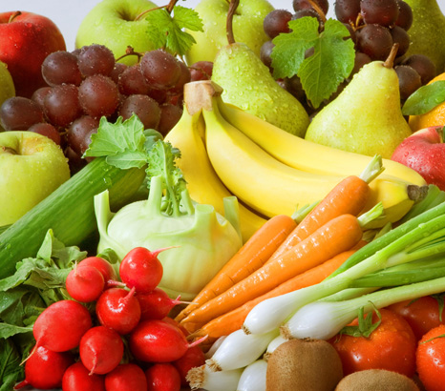
White, brown and tan fruits and vegetables promote heart health and may reduce cancer risks. Try bananas, brown pears, cauliflower, dates, mushrooms, onions, parsnips, turnips, white potatoes, white corn and white peaches.
Choose a variety of colors when shopping for produce. And if you’re looking for fruits or vegetables that are out of season, opt for frozen or dried choices that are available throughout the year. Colorful meals are not only more flavorful, they contain a variety of nutrients that are essential to you and your family’s health.
For more information on National Nutrition Month, visit www.eatright.org.

Did You Know?
March is National Nutrition Month and Poison Prevention Week is March 20-26.


FLEXIBILITY
HYGIENE
STRENGTH
MENTAL
HEALTH
GOOD
DIETING
Turkey Meatloaf

This brochure is for informational purposes only and is not intended as medical advice. For further information, please consult a medical professional.
© 2011 Zywave, Inc. All rights reserved.

Never leave loose pills out. Even if you’re leaving the room for a few seconds, this can be enough time for children or pets to ingest the pills.
Be mindful when children or pets visit your home. You may not have children or pets of your own, but it’s important to put away any medications or chemicals when you have visitors.
Never use cups or soft drink bottles for household chemicals or cleaners. Both children and adults could mistake these for actual drinks.
Never refer to medicine as “candy” when administering it to a child. The child may remember this and be tempted to take medicine on his or her own.
Pay attention to tamper-proof and child-resistant packaging. If a product looks like it’s been tampered with, do not risk using it.

Watch for IRS Tax Return Scams

March 2011
Poison Prevention, cont…

Always read the labels and instructions of potentially hazardous products and medications. This is the best way to avoid adverse effects or recognize an adverse effect should the product or medication be ingested.
Never create your own cleaning solutions. A poison control center will not be able to give you proper instructions should anyone ingest the cleaning solution.
Keep children out of the way when using pesticides. Make sure toys are removed from the area before applying, and never leave pesticides unattended while in use.
If you think someone has been poisoned from ingesting medication or a household chemical, call 1-800-222-1222 to be connected to your local Poison Control Center any time, 365 days a year. Post this number by your home telephone or save it in your cell phone in case of an emergency.


Protect yourself from online identity theft and other scams that increase during the tax filing season by taking the following precautions. Tax return scams have been known to impersonate the logo, names and design of the IRS or U.S. Department of Treasury to mislead taxpayers and lure them into providing personal and financial information.
Watch for e-mails that:
- Threaten to add additional taxes or withhold the tax refund should you not respond to the e-mail.
- Request personal or financial information. The IRS does not request such information through e-mail, nor do they send any communication requesting tax account information, PINs, passwords or similar access information for credit cards, banks or financial accounts.
If you receive a suspicious IRS-related e-mail do not reply, do not open any attachments and do not click any links. Forward the e-mail to the IRS at phishing@irs.gov. After forwarding the e-mail delete it from your inbox and outbox.

Looking for a low-fat, low-sodium twist to an old favorite?
Try this heart-healthy recipe for turkey meatloaf.
1 lb. lean ground turkey
½ cup regular dry oats
1 large egg
¼ cup chopped sweet onion
¼ cup low-sodium ketchup
Combine all ingredients and mix well. Bake in a loaf pan at 350 degrees F for 25 minutes or until the internal temperature reaches 165 degrees F. Slice and serve with your favorite side of vegetables. Serves 5.


